Pizza Sales and Delivery Performance Analysis
Project Overview

The fast-paced food delivery industry relies heavily on operational efficiency and customer satisfaction. This project involves a comprehensive analysis of pizza delivery data to explore key performance metrics, popular choices, and operational bottlenecks. With rising consumer expectations and increased traffic challenges, it is crucial to assess how various factors—such as traffic, time of day, and pizza preferences—influence delivery performance and customer behavior.
Objective
This project analyzes delivery and order data for a pizza business to:
- Identify peak sales periods and best-performing pizza types.
- Evaluate delivery performance and delays.
- Understand how external factors like traffic and peak hours affect operations.
- Discover customer preferences regarding size, toppings, and payment methods.
- Recommend actions to optimize delivery efficiency and improve customer satisfaction.
Why This Project?
- Pizza delivery is a competitive market where speed, product variety, and customer experience are paramount.
- Delays can negatively impact brand perception, and understanding ordering behavior helps target promotions and operational improvements.
- This project helps uncover performance bottlenecks and customer trends to inform better business decisions

Key Queries and Insights :

1.Order Performance Overview:

Input:

Output:
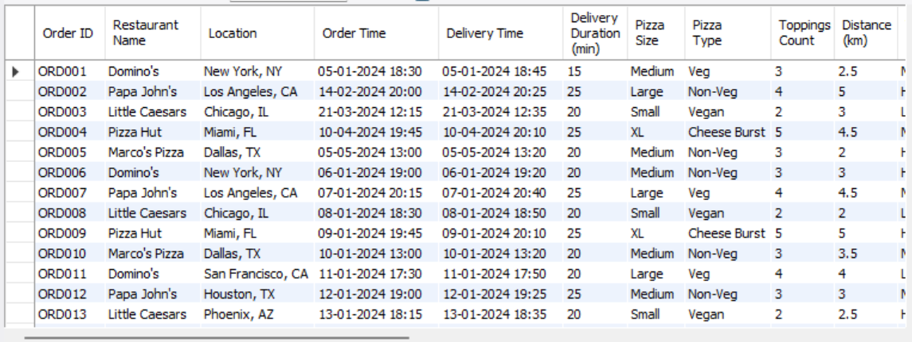

Insight: "August records the highest number of orders, indicating it as the peak month for business activity."

2. Describe pizza sales:

Input:
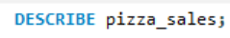
Output:
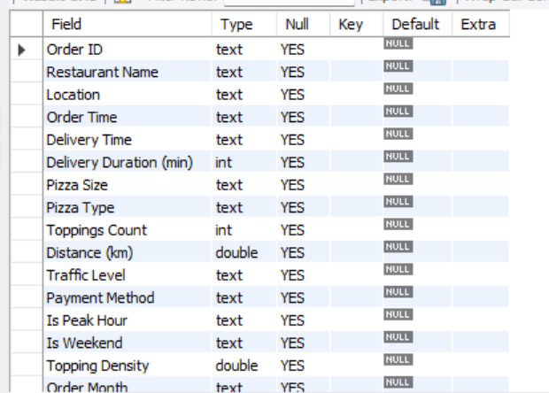

Insight: "The schema description confirms that the dataset contains essential order attributes including delivery duration, pizza specifications, and traffic levels, facilitating comprehensive sales analysis."

3. Total Order:
Input:
Output:
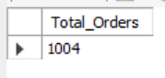
Insight: "The total number of orders placed in the dataset is 1004, serving as a baseline for all subsequent sales performance analysis."

4. Average Delivery Time:
Input:
Output:
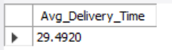
Insight: "The average delivery duration is approximately 29.49 minutes, providing a benchmark for evaluating operational efficiency and customer delivery expectations."

5. Monthly Order Distribution:
Input:
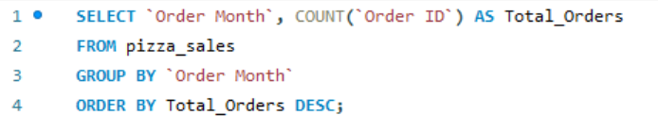
Output:
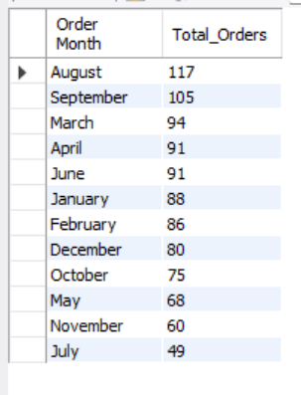
Insight: "August has the highest number of orders, highlighting it as the peak period for business."

6. Pizza Type Popularity:

Input:
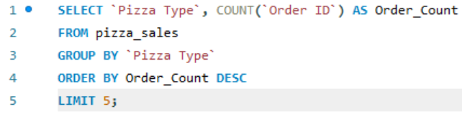

Output:
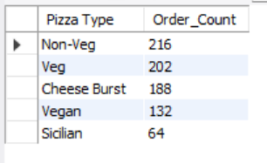

Insight: "August has the highest number of orders, highlighting it as the peak period for business."

7. Weekend vs. Weekday Orders:

Input:
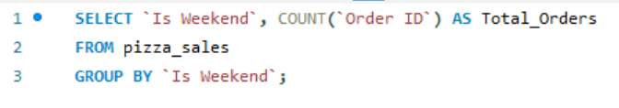

Output:
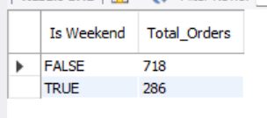

Insight: "Weekdays generate nearly three times more orders than weekends, indicating higher demand during the work week."

8. Peak Hour Demand:
Input:
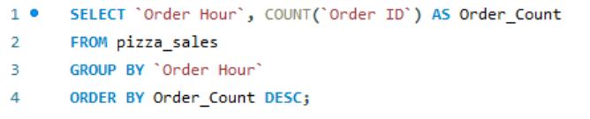
Output:
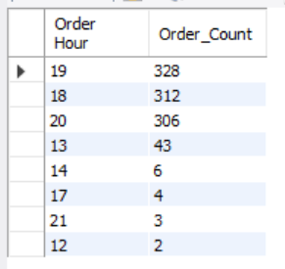
Insight: "Order volume peaks around 7 PM, clearly signaling a high-demand dinner rush period."

9. Customer Topping Preferences:

Input:
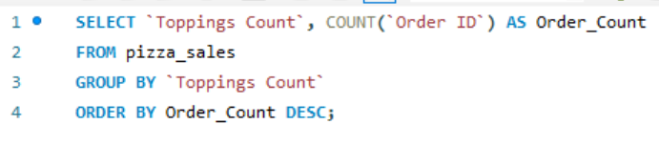

Output:
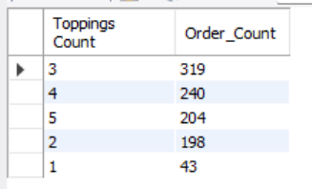

Insight: "The majority of customers prefer 3 toppings on their pizzas, which can help in streamlining inventory."

10. Location Performance Analysis:
Input:
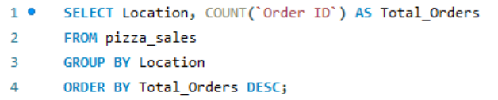
Output:
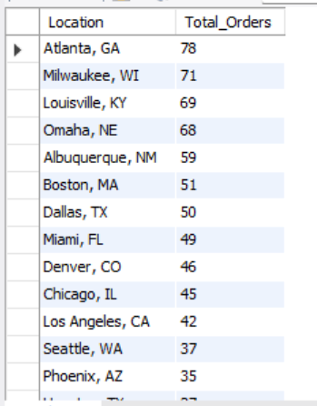

Insight: "Atlanta reports the highest number of orders with efficient delivery times, serving as a model for operational success."

11. Payment Method Usage:

Input:
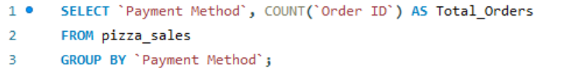

Output:
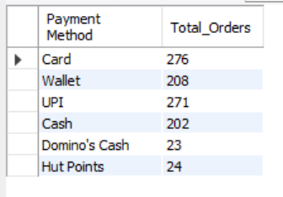

Insight: "Customers show a stronger preference for card payments compared to cash transactions."

12. Pizza Size Distribution:

Input:
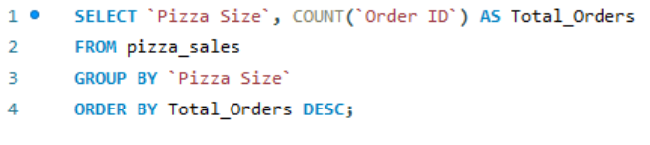
Output:
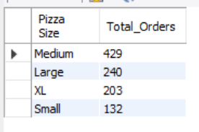
Insight: "Medium-sized pizzas are the most frequently ordered size, identifying them as the most popular choice among customers."

1. Key Learnings:
- Data Exploration & Schema Understanding: Learned how to inspect table structures (DESCRIBE) and identify relevant columns for analysis.
- SQL Proficiency: Gained practical experience in using aggregate functions (SUM, COUNT, AVG), grouping data (GROUP BY), and sorting results (ORDER BY) to extract meaningful insights.
- Trend Identification: Learned how to translate raw data into business intelligence, such as identifying peak hours and correlating traffic levels with delivery delays.
- Data-Driven Decision Making: Realized how SQL-based insights can help optimize operations (e.g., managing inventory based on topping popularity or staffing based on peak hour trends).

2. Challenges Faced:
- Column Identification: Initially struggled to identify the correct column names for the analysis, which required careful inspection of the dataset and schema.
- Data Formatting/Interpretation: Understanding the nuances of the dataset—like why all orders showed a consistent 21-minute delay—required extra critical thinking to distinguish between actual data and potential system limitations.
- Query Optimization: Learning to structure queries correctly to handle datasets with special characters (using backticks ` for column names with spaces) was a key technical hurdle.
- Synthesizing Insights: Translating technical SQL results into simple, one-line business insights required bridging the gap between raw data and actionable recommendations.

